Restaurant Lead & Appointment Automation System
GoHighLevel | Voice Agents | Inbound & Outbound Automation | CRM | Email

Project Overview
Built a GoHighLevel automation system for a restaurant to manage inbound leads, outbound follow ups, appointment bookings, and customer communication from one CRM.
The setup includes separate workflows for inbound and outbound campaigns, dedicated agents, appointment handling, and automated email communication.
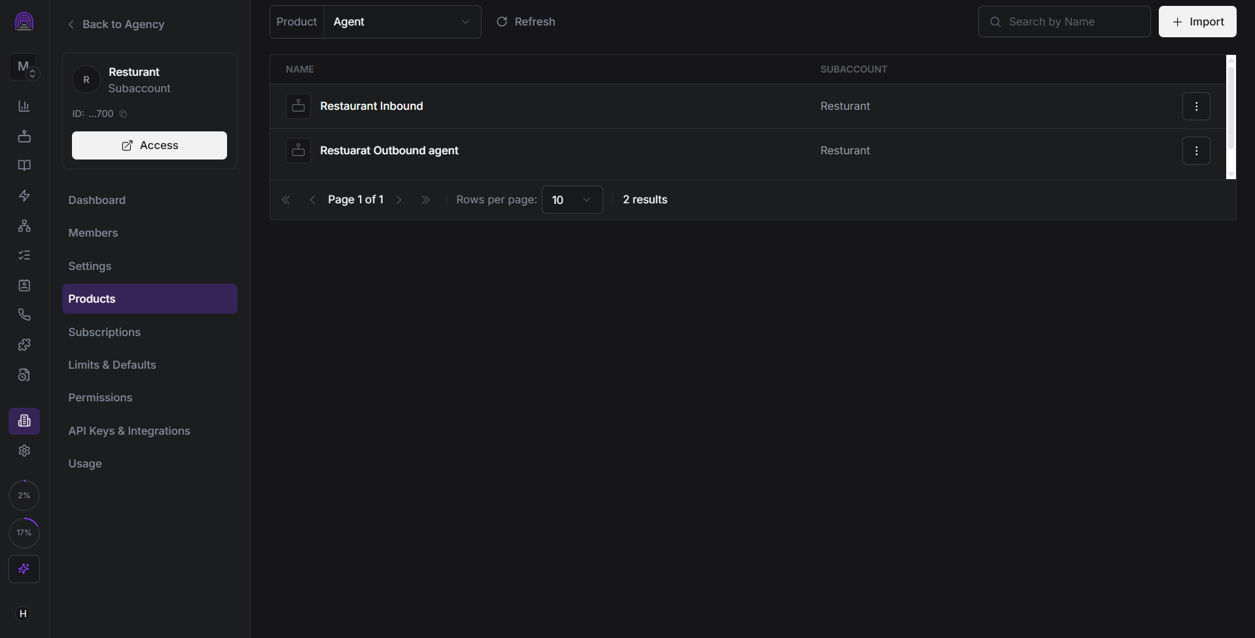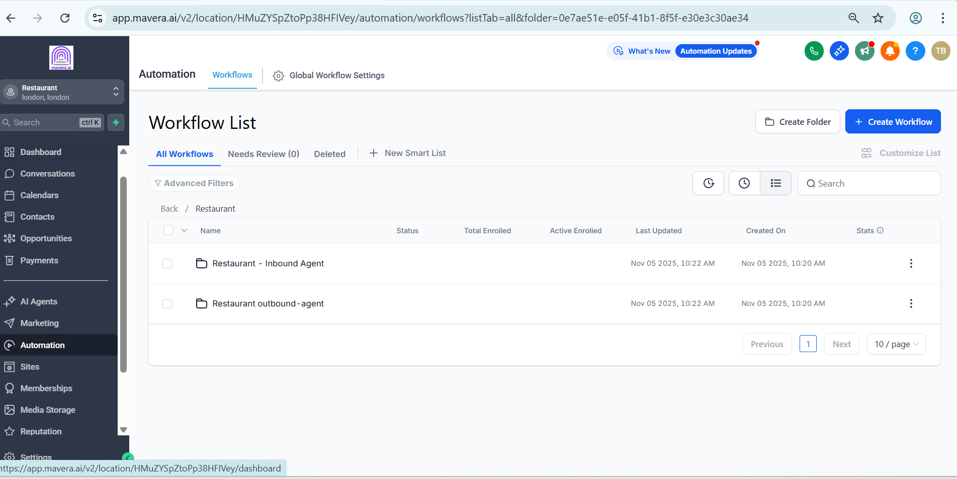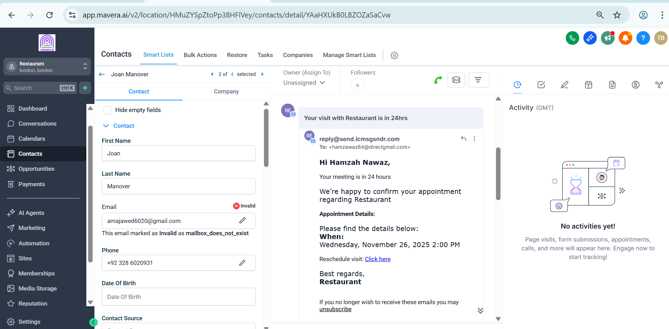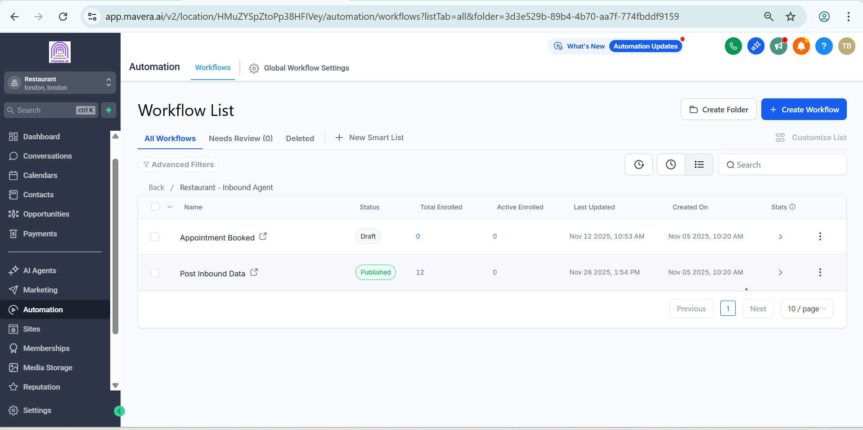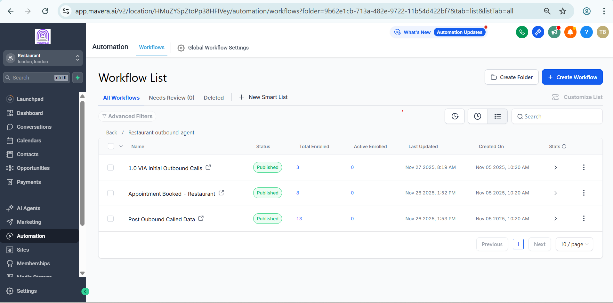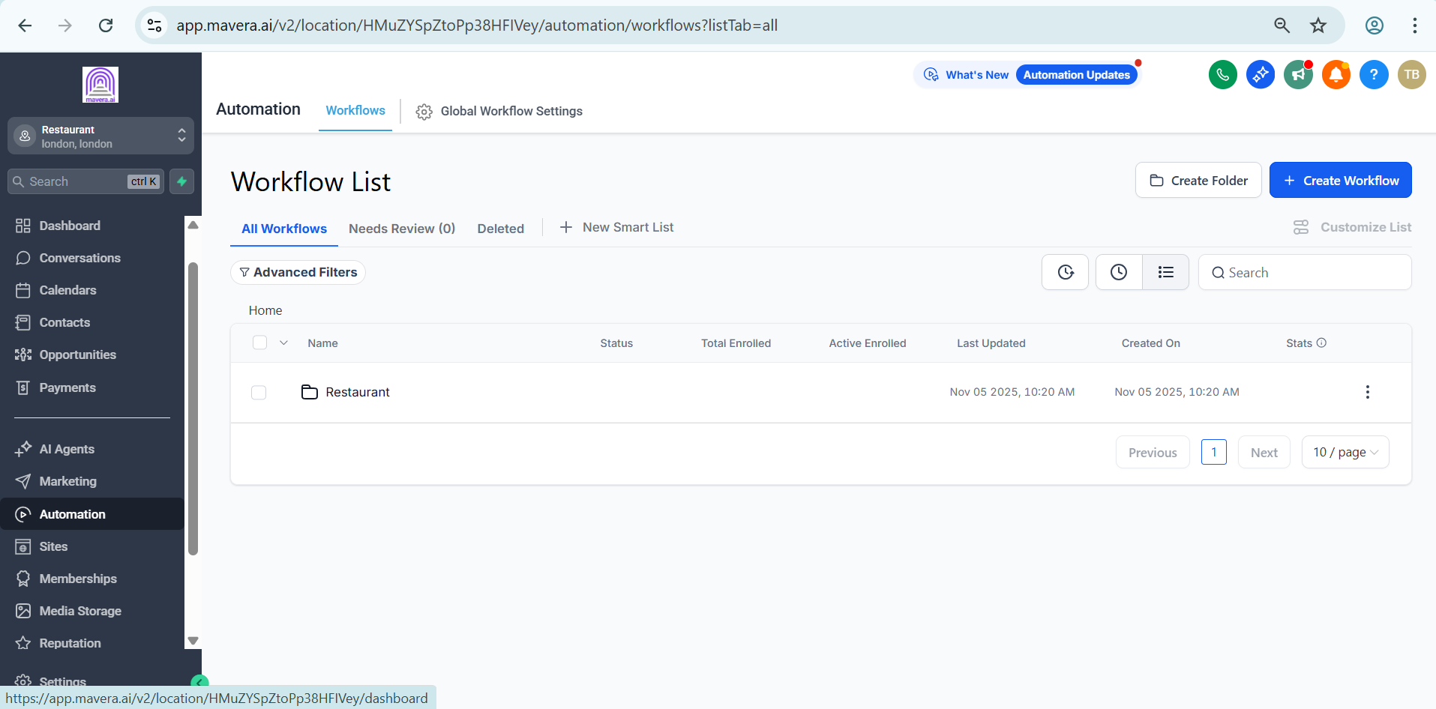

CRM & Subaccount Setup
The system was organized inside a dedicated restaurant subaccount with separate automation areas for:
• Inbound Agent
• Outbound Agent
• Appointment Booking
• Lead Follow Ups
• Customer Email Communication

Outbound Automation
The outbound setup includes workflows for:
• Initial outbound calls
• Appointment booking
• Post outbound call handling
Leads are enrolled into the appropriate workflow and moved through the follow up process based on the outcome of the interaction.

Inbound Automation
The inbound setup handles incoming customer interactions and connects them with the appropriate booking and follow up workflows.
This allows new inquiries to be processed without relying entirely on manual responses.

Appointment & Email Automation
The system also manages appointment related communication through GoHighLevel.
Customer records contain contact information and conversation history, while automated emails are used to confirm appointment details and provide the required information to the customer.

Agent Structure
Separate inbound and outbound agents were configured within the restaurant subaccount, keeping the two communication processes organized and easier to manage.

Technology
• GoHighLevel
• CRM
• Voice Agents
• Workflow Automation
• Appointment Booking
• Email Automation

Result
A centralized restaurant lead management system that connects lead generation, inbound and outbound communication, appointment booking, follow ups, and customer emails inside GoHighLevel.
The setup gives the restaurant a structured process for handling leads and customer interactions from the first contact through appointment confirmation.

